Design

Cards Manager

Introduction:-
One of the key components of the Monopoly game is ‘Drawn Card’ function (see Use Case 6). When a player lands on the ‘Community Chest’ or ‘Chance’ tile, then the Draw Card action is called into play. The CardsManager class deals with the actions involved in this process.

Class Breakdown:-
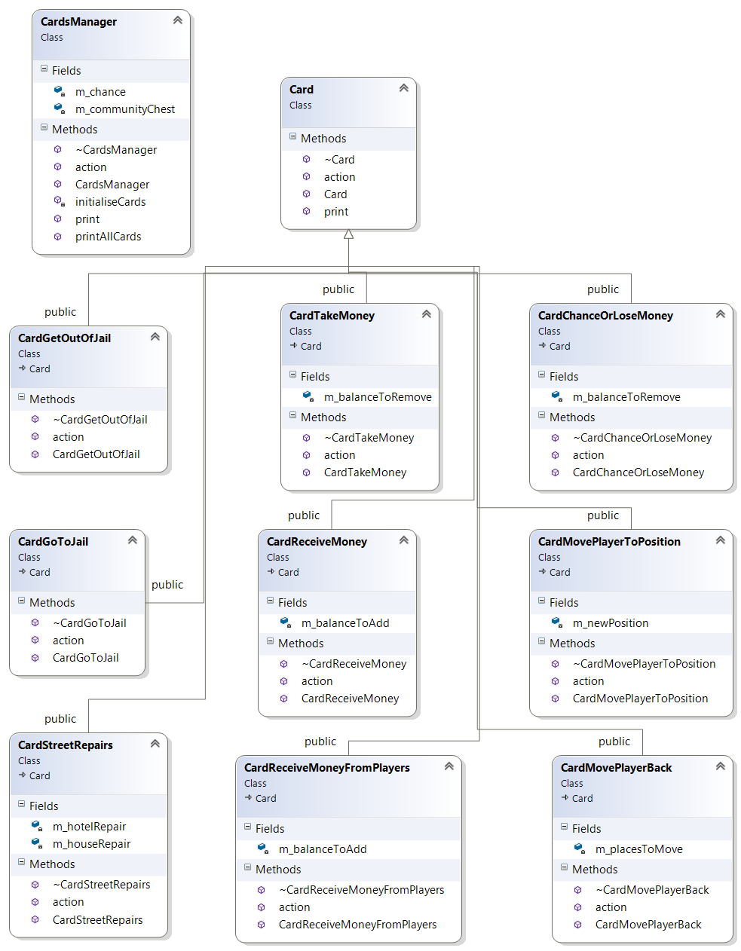
- Within the constructor of ‘Cards Manager’, during initialisation, two files are read into 2 string vectors; the Chance and Community Chest text files.
- At the next stage, each string entry in the community chest and chance vectors are further parsed and segmented up so as to be made into a Card object
- There are 9 types of card altogether. In the text files, these types are denoted by flags, which are the characters at the beginning of the line. Each type of card takes 0 to 2 parameters. These parameters are denoted straight after the flag. Finally each Card has an instruction. Below is an example of

h 40 115 You Are Assessed for Street Repairs. £40 per House, £115 per Hotel

- When the line from the vector is passed, the first ‘word’ is parsed into a temporary string, which is then matched with a set of comparison conditions i.e. the flags.
- As shown in the class diagram above, there are 9 classes which inherit from Card. These represent the different types of card and influence and manipulate the players accordingly. Each of these classes contains an ‘which take 0 to 2 parameters. They also contain an action with takes a reference to the players as a parameter.
- The Player’s statistics are manipulated via the PlayerManager, through the action.

FLAGS | Description | Class
b | Lose Money or Pay Fee | new CardChanceOrLoseMoney(moneyToRemove)
f | Get Out of Jail Free | new CardGetOutOfJail()
g | Player Receives Money | new CardReceiveMoney(moneyToAdd)
gp | Player Receives Money from Other Players | new CardReceiveMoneyFromPlayers(moneyToAdd)
h | Pay for Houses and Hotels | new CardStreetRepairs(house, hotel)
j | Go To Jail | new CardGoToJail()
l | Player Loses Money | new CardTakeMoney(moneyToRemove)
m | Move Player to Position | new CardMovePlayerToPosition(boardPosition)
mb | Move Player back an amount of Spaces | new CardMovePlayerBack(spacesToMove)

- Once all of the cards have been created, they are stored into a vector of cards for ‘Community Chest’ and ‘Chance’.
- CardsManager itself has an action. This is called whenever a player lands on the Community Chest or Chance tile. The name of the tile is passed to this action, as well as the reference to the player who landed on it.
- A random number is then generated and passed into the appropriate card vector, and the chosen card’s action is performed.

Tile

Introduction:-
Each item on the Monopoly board is represented by a Tile. Each is separated into types which are defined in the Board text file. The most prominent type of tile are the Normal Property tiles. Each of these belong to a group, denoted by colour. Each group consists of 2 or 3 properties. Group Manager is used to manage the relations between these tiles, as some operations e.g. building houses cannot be performed by players until the player owns all of the properties in a group.

Class Breakdown:-
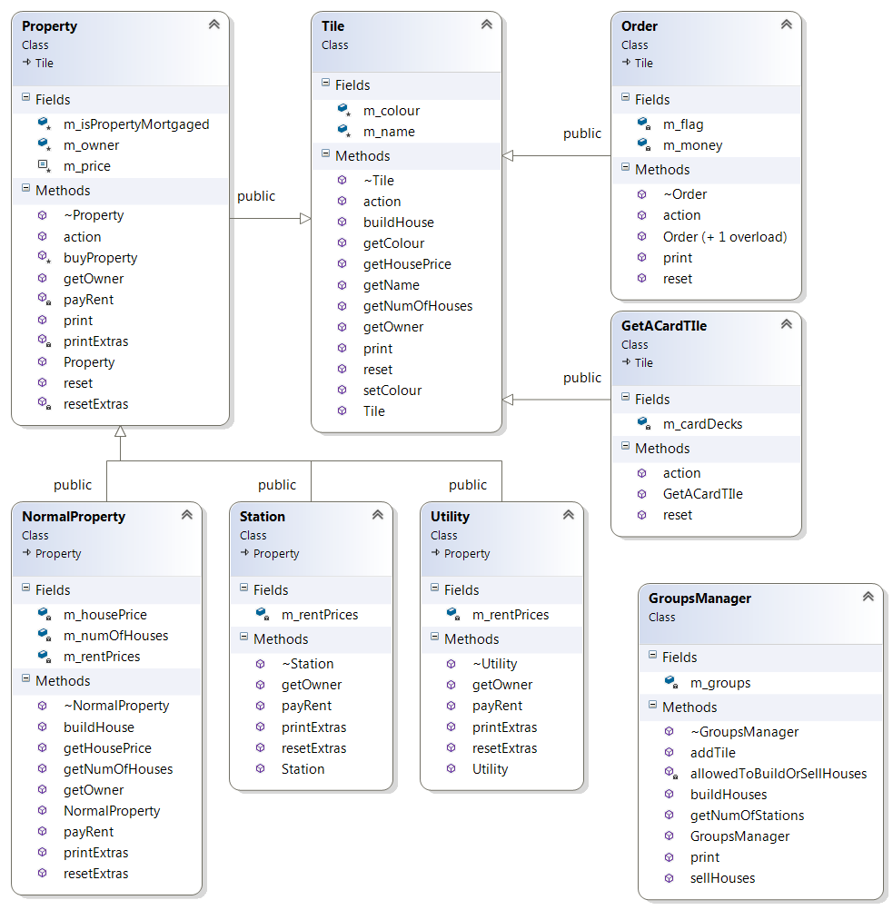

- When the game is loaded, the first component to be loaded is the board. The board items (tiles) are defined in the Board text file.
- The structure of each line is such that they are assigned CELL NUMBER, FLAGS, PARAMETERS and NAME.
- There are FOUR main types of tiles
  - Order:- These are the tiles which are integral to the game (and should not be changed). These include the GO, JAIL, FREE PARKING, GO TO JAIL, SUPER TAX, COMMUNITY CHEST and CHANCE tiles.
  - Normal Property:- These are the majority tiles. Each of these tiles are part of a group of properties. It’s unique feature is that once the player owns all of the properties in a group, they are able to build houses and hotels on them to increase the amount of rent they receive
  - Station:- Railway Stations are all the same price. However the rent chargeable by the owner is dependent on how many other stations they own.
  - Utility:- Utilities (WATER WORKS and ELECTRIC COMPANY) are the same price. However the rent chargeable by the owner is dependent on how many other stations they own. It is also dependent on the value of the second dice roll.
- Normal Property, Station and Utility all inherit from the Property class. Property keeps track of the player who owns the property, and deals with calculating the amount of rent to charge any opposing player who lands on the tile.
FLAGS | Description | Class
p n | Normal Property | new NormalProperty(name,price,housePrice,rentPrices)
c | Cards | new GetACardTIle(name,m_cards)
o p | Tax Tiles | new Order(name,"p",money)
o j | Go To Jail | new Order(name,flag)
o f | Free Parking | new Order(name,flag)
p s | Railway Station | new Station(name,price,rentPrices)
p u | Utility | new Utility(name,price,rentPrices)

